

**GRADE: UKG HOLIDAY FUNSHEET 5**

**NAME: DATE OF ISSUE: 25/04/2022**

**ROLL NO: DATE OF SUBMISSION: 28/04/2022**

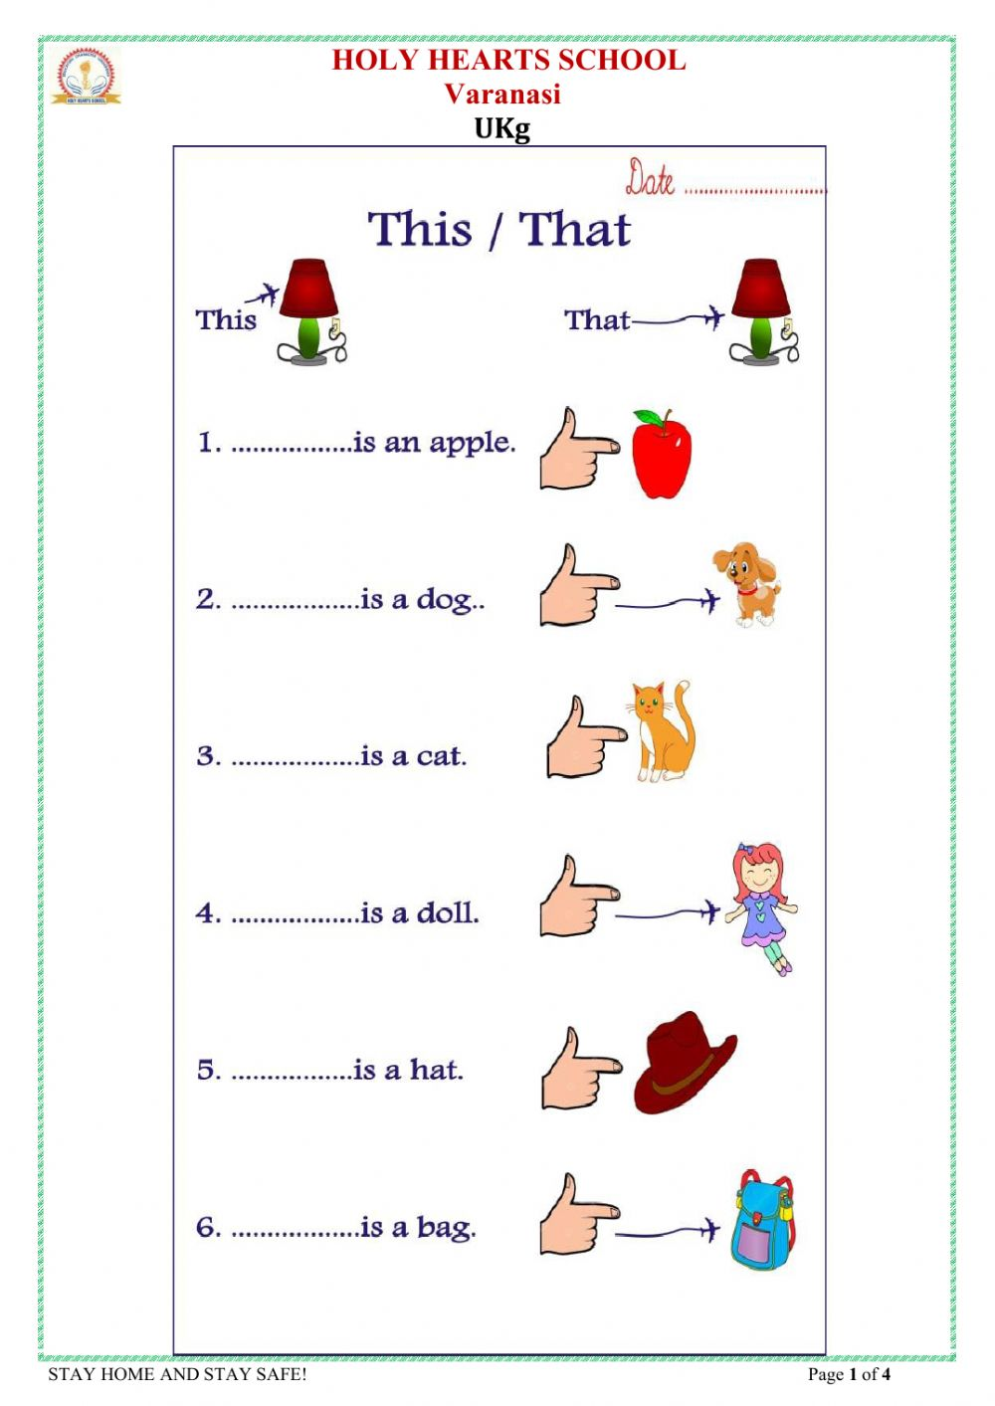

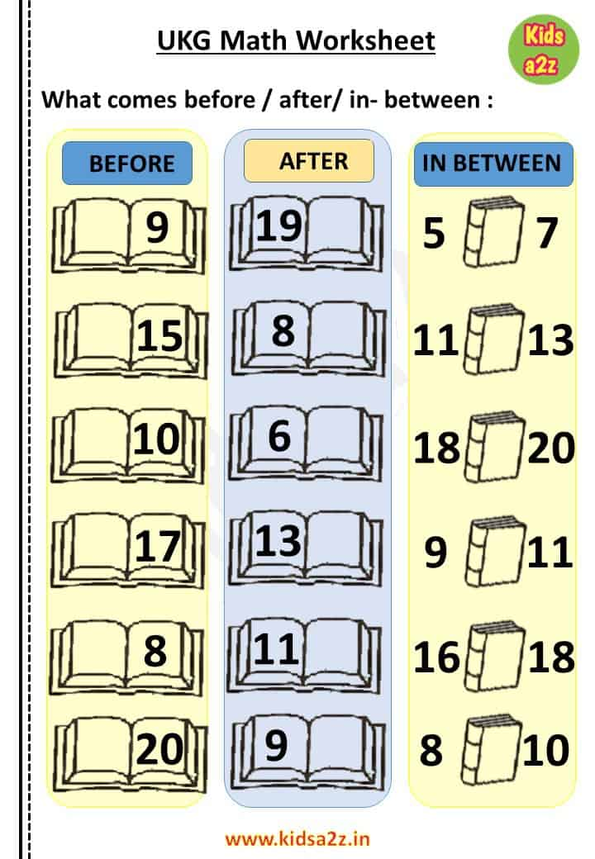

MAKE TEDDY BEAR USING NEWSPAPER:

